**Employee management system**

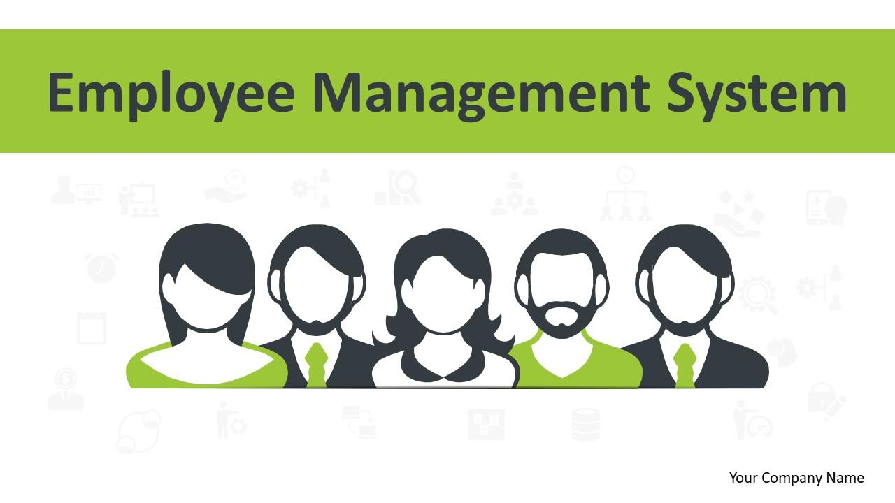

**EMPLOYEE MANAGEMENT SYSTEM**

**FINAL PROJECT ON SQL**

**NAME – VIVEK NAYAK**

**BATCH – T406**

**FACULTY INCHARGE – SANDIP JAISWAR**

**ABSTRACT:**

Employee management system is an application based system, having two applications developed, one for employers to manage employee details and another for employees to mark their attendance. Every organization whether government or private uses an information system to store data of their staff. However, in India it is found that many small scale industries use pen and paper to keep a record. However, there are many advanced technology systems available that can do this work but they all are costly for these low level industries. This paper discusses making a system for solving problems for them at a cheaper cost. This system will mark attendance of each employee and calculate the salary of them at the end of month. It also calculates overtime and total working hours of each employee. As in small scale each company has their own holiday’s preference and variable week off for employees, so all this power is given to the employer to manage holidays and week days of each employee separately. It saves lots of time and has no error in pay calculation hence preventing clashes between HR Team and employees. So that both employer and employee can focus on their work to develop their company.

**AIM OF PROJECT:**

THE MAIN GOAL OF PROJECT OF THE EMPLOYEE MANAGEMENT SYSTEM IS TO ENSURE THAT MANAGE EMPLOYEE INFORMATION, SUCH AS PERSONS DETAILS, JOB TITLES, SALARIES, LEAVES AND PAYROLL USING SQL.

**INTRODUCTION:**

An HR management system streamlines the HR functions by managing business operations by the department.

Employee management systems are designed to monitor, assess, and control the working hours of employees in order to utilize their resources efficiently. The payrolls are also done on time with the help of payroll software.

Employee Management Software or labour management is an organizational process that meets the productivity, social, and practical requirements of employees. Also, it helps recruit employees, on board, and enhance their performance up to mark.

Employee management provides many direct and indirect responsibilities to human resources. Have a look at some of them:

* Investment
* Engagement and Retention
* Productivity Management
* Benefits and Payroll

**OBJECTIVE OF PROJECT:**

1. THE COMPANY WILL BE ABLE TO EASILY TRACK THE DETAILS OF EMPLOYEES, JOB QUALIFICATION AND SALARY.
2. TO DEMONSTRATE A WELL- DESIGNED DATABASE TO STORE EMPLOYEE INFORMATION.
3. IT WILL GIVE PROPER RELATION REGARDING WHICH EMPLOYEES WORKING AND HAVING A LEAVE.
4. MAINTAINED THE SALARY, ATTENDANCE, EVENTS, LEAVES AND REQUESTS.

**ENTITY RELATIONSHIP DIAGRAM**

|  |
| --- |
| **EMPLOYEE** |
| EMP_ID(PK) |
| FNAME |
| LNAME |
| GENDER |
| AGE |
| CONTACT |
| EMP_EMAIL |
| ADDRESS |
| EMP_PASS |

|  |
| --- |
| **JOB_DEPARTMENT** |
| JOB_ID(PK) |
| JOB_DEPT |
| JOB_NAME |
| DESCRIPTIONS |
| SALARY_RANGE |

|  |
| --- |
| **SALARY** |
| SALARY_ID(PK) |
| JOB_ID(FK) |
| AMOUNT |
| ANNUAL_EXPENSE |
| BONUS |

|  |
| --- |
| **QUALIFICATIONS** |
| QUAL-ID(PK) |
| EMP_ID(FK) |
| POSITIONS |
| REQUIREMENT |
| DATE_IN |

|  |
| --- |
| **PAYROLL** |
| PAYROLL_ID(PK) |
| EMP_ID(FK) |
| JOB_ID(FK) |
| SALARY_ID(FK) |
| LEAVE_ID(FK) |
| DATE_PAYROLL |
| REPORT |

|  |
| --- |
| **LEAVES** |
| LEAVE_ID(PK) |
| EMP_ID(FK) |
| DATE_LEAVE |
| REASON |

**WE HAVE 5 TABLES OF EMPLOYMENT MANAGEMENT SYSTEM**

* EMPLOYEE
* JOB_DEPARTMENT
* SALARY
* QUALIFICATION
* LEAVES
* PAYROLL

**STRUCTURE OF TABLE:**

* **EMPLOYEE**

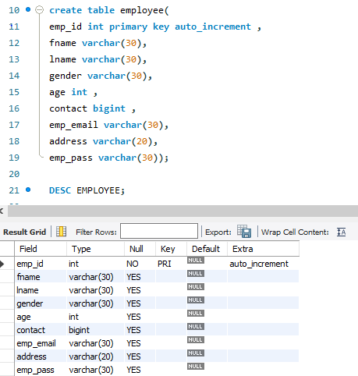

* **JOB_DEPARTMENT**

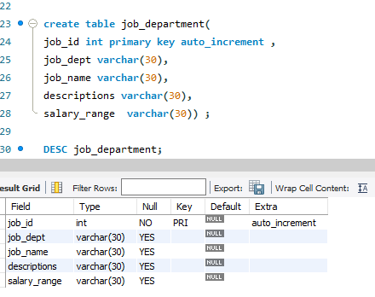

* **SALARY**

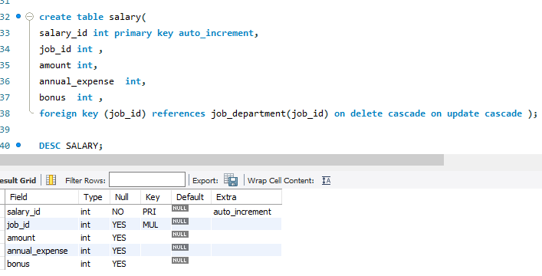

* **QUALIFICATION**

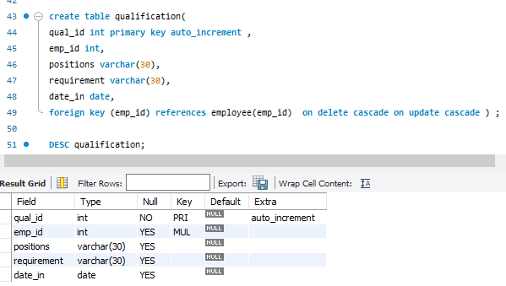

* **LEAVES**

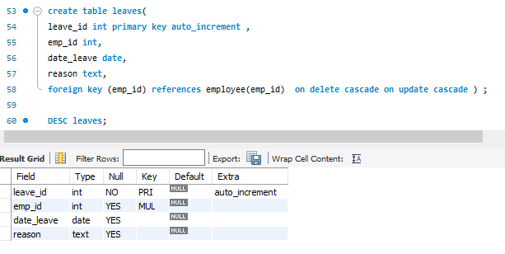

* **PAYROLL**

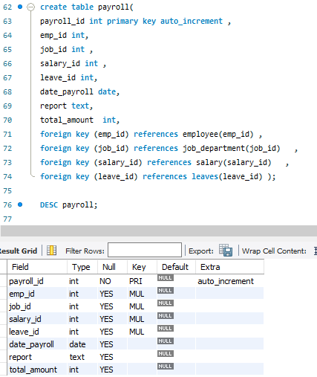

**INSERT VALUES INTO TABLE:**

* **EMPLOYEE**

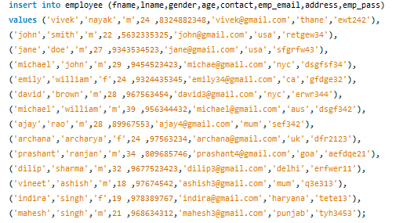

* **JOB_DEPARTMENT**

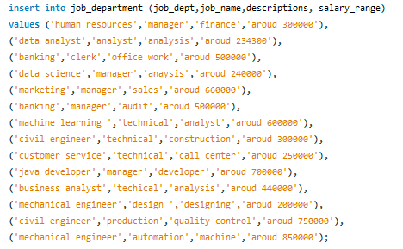

* **SALARY**

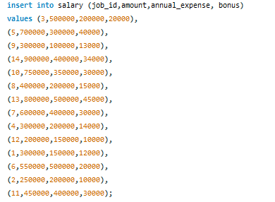

* **QUALIFICATION**

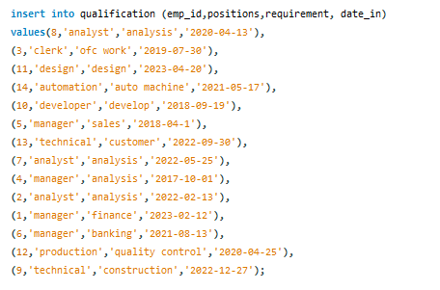

* **LEAVES**

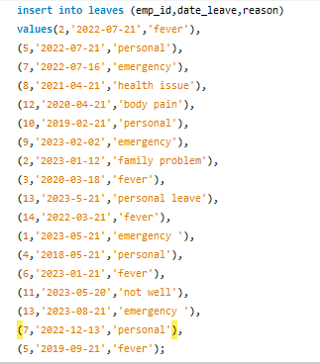

* **PAYROLL**

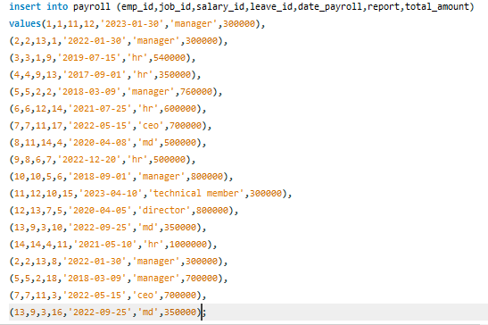

**CONTENTS OF TABLES:**

* **EMPLOYEE**

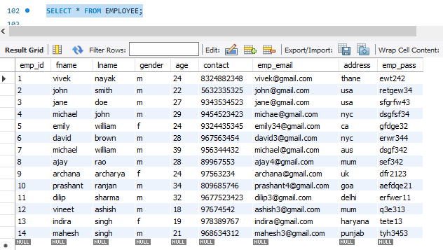

* **JOB DEPARTMENT**

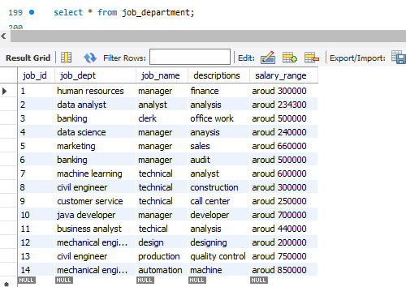

* **SALARY**

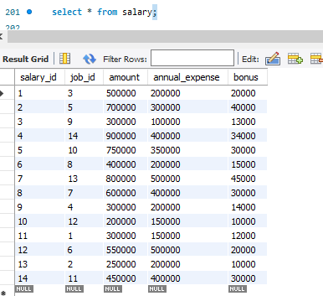

* **QUALIFICATION**

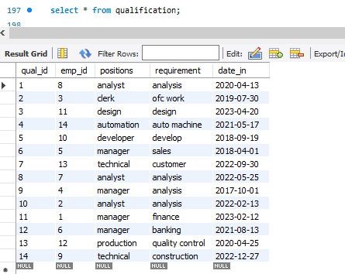

* **LEAVES**

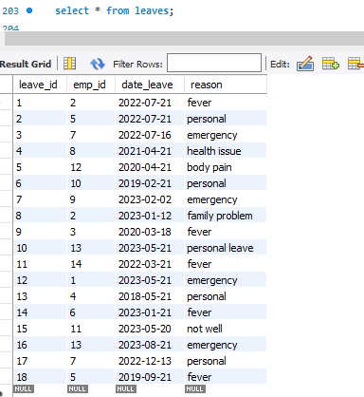

* **PAYROLL**

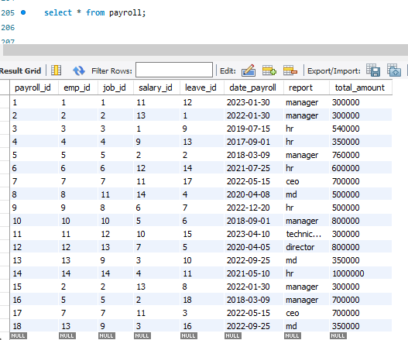

**ALTER TABLE**

* **ADD COLUMN**

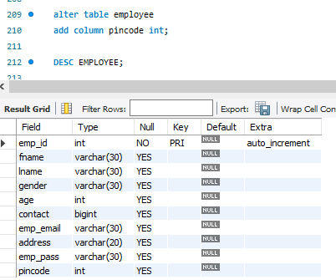

* **DROP COLUMN**

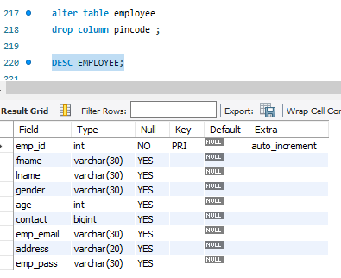

**UPDATE COLUMN**

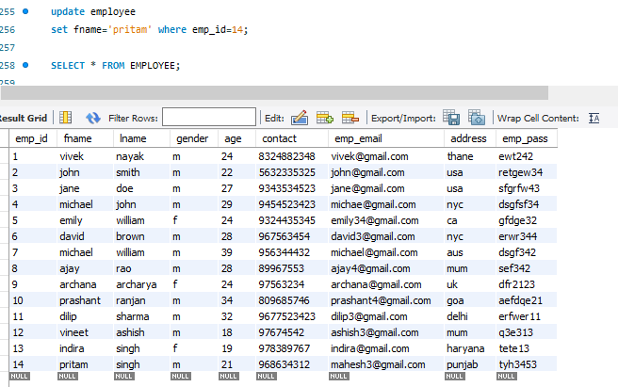

**CHANGE COLUMN NAME AND DATATYPE**

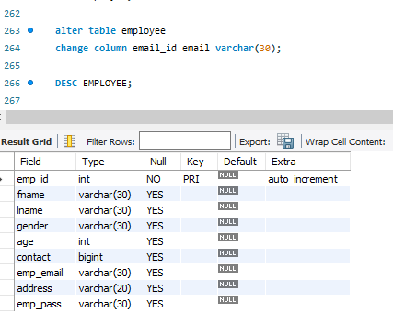

**MODIFY DATATYPE CONSTRAINT OF EXISTING COLUMN**

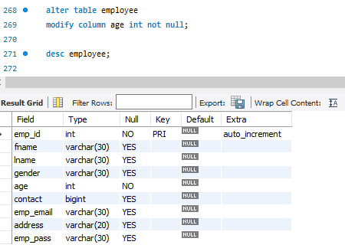

**RENAME TABLE**

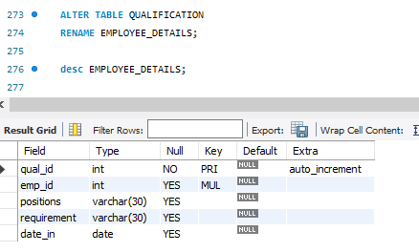

**WHERE CONDITION**

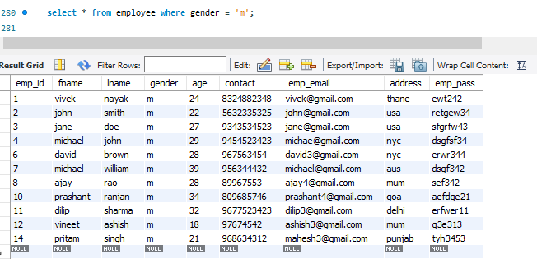

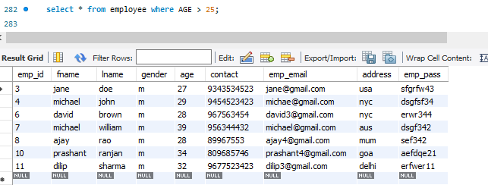

**BETWEEN OPERATOR**

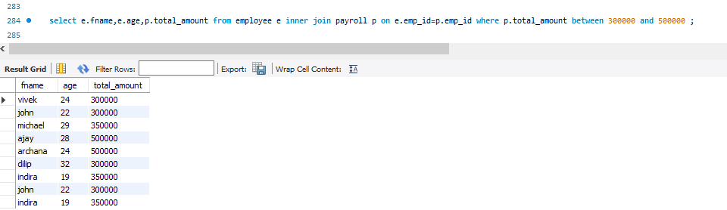

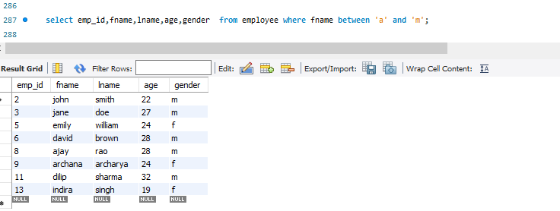

**LIMIT FUNCTION**

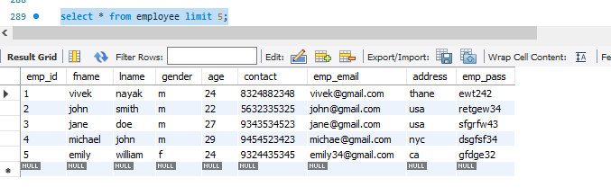

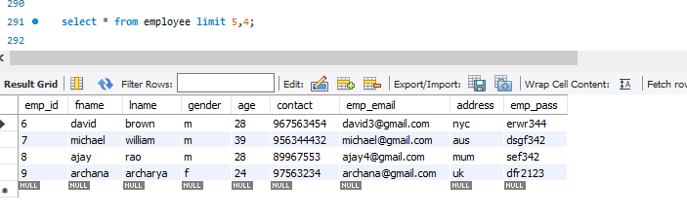

**LIKE OPERATOR**

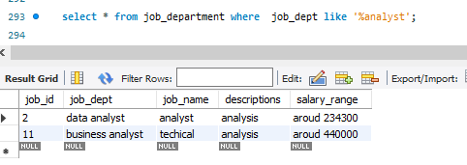

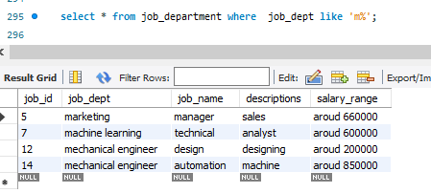

**ORDER BY CLAUSE**

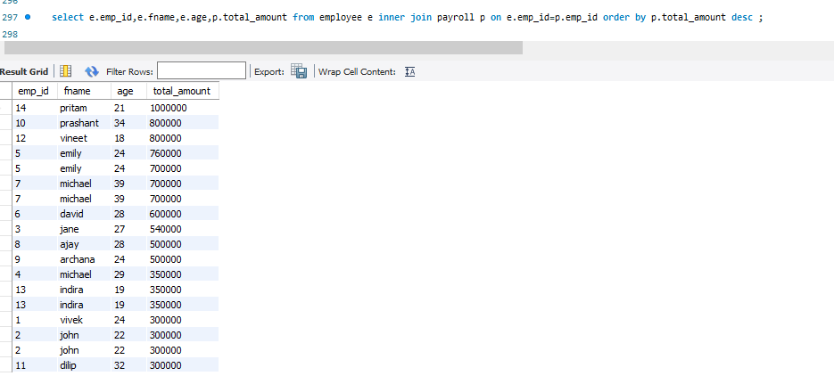

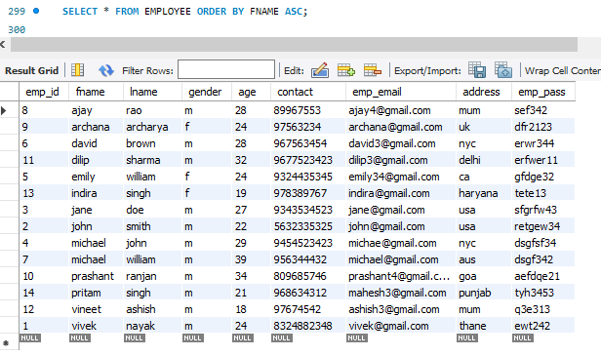

**DISTINCT SYNTAX**

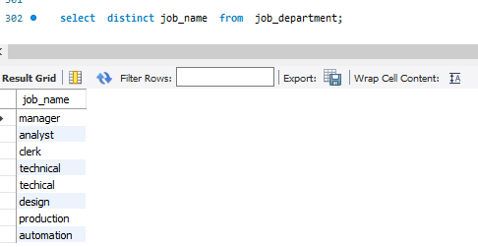

**HAVING CLAUSE**

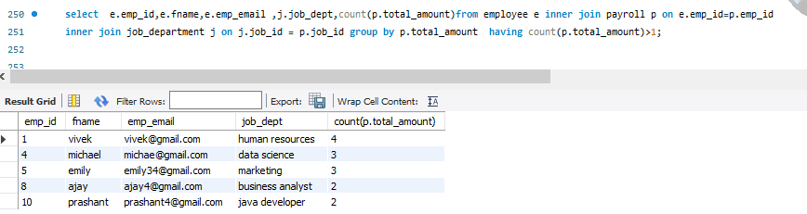

**JOIN WITH LIMIT**

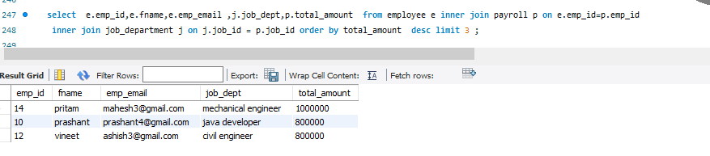

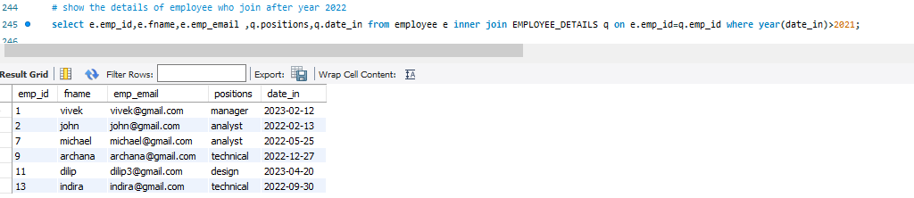

**JOIN:**

**LEFT JOIN:**

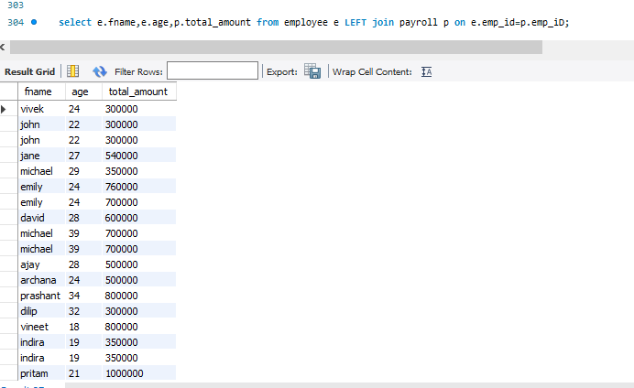

**RIGHT JOIN:**

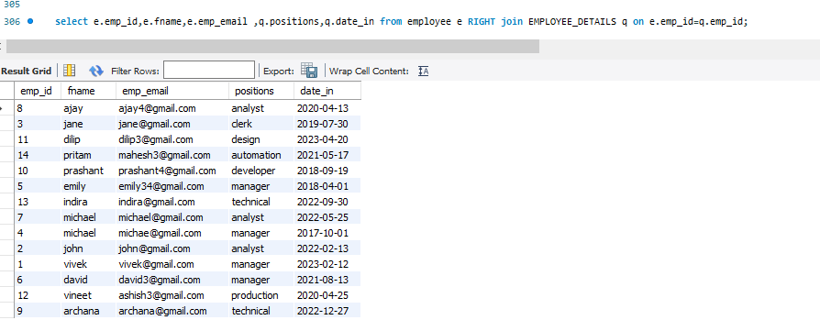

**NON-EQUI JOIN:**

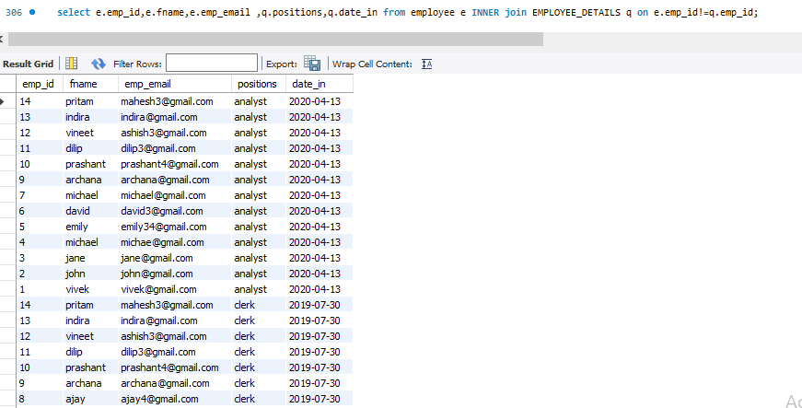

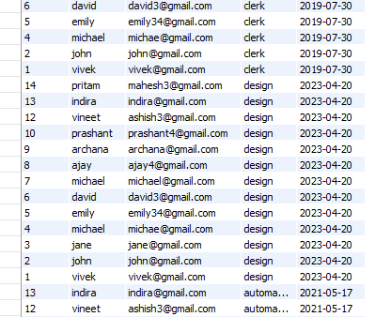

**CONCAT:**

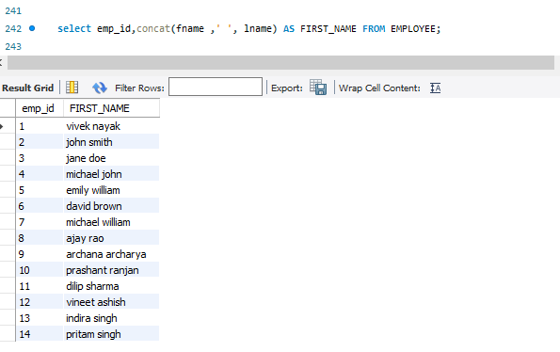

**LOWER:**

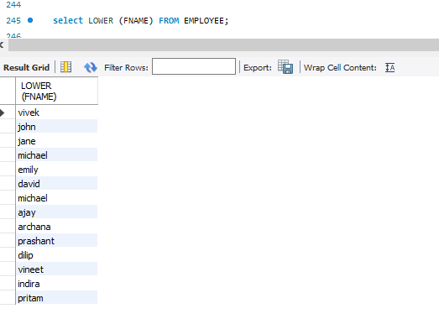

**UPPER:**

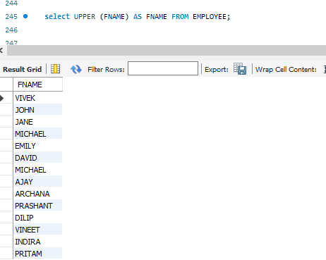

**REVERSE:**

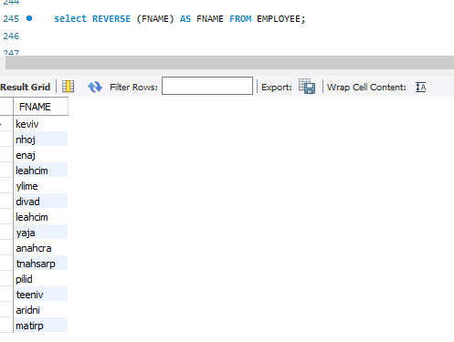

**SUBSTRING:**

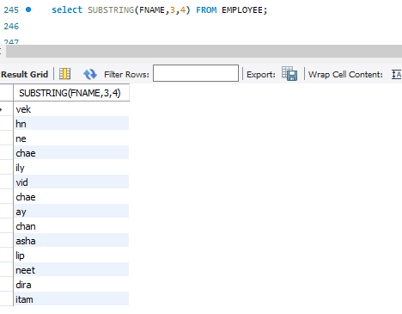

**LENGTH:**

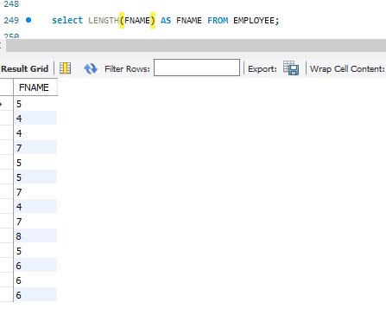

**AGGREGATE FUNCTION**

**AVERAGE:**

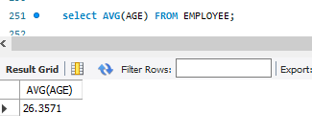

**MIN:**

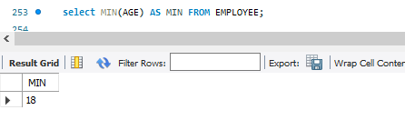

**MAX:**

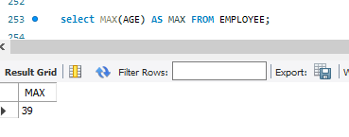

**SUM:**

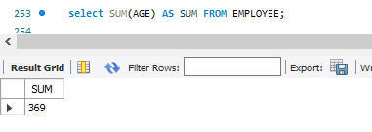

**COUNT:**

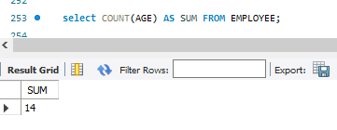

**THANK YOU**